**SPRINT 1 PLAN**

Project Name: Boba Tracker

Team Name: Boba Peeps

**GOALS:**

For this sprint, our team goals are to create an entry form where users can track their drink information and display this information in a chart.

**TASKS**

User story 1: As a user, I want to be able to input how much I spend on each drink and view it. (20 Story Points)

* Create an entry form for entering drink name, drink cost, and optionally the sugar amount in the drink.
  + Time estimate:
* Set up database for storing user data
  + Time estimate:
* Total for user story 1:

User story 2: As a user, I want to view my information in a chart. (8 Story Points)

* Task
  + Time estimate:
* Total for user story 2:

User story 3: As a developer, I want an attractive, well organized layout that will motivate users to use the app. (5 Story Points)

**TEAM ROLES**

* Jarod Alvarez: Product Owner
* Maggie Lee: Initial Scrum Master
* Johana Martinez: Developer
* Thai Nguyen: Developer
* Chi Huynh: Developer

**INITIAL TASK ASSIGNMENT**

* Jarod Alvarez
  + User story: User Story 1
  + Initial Task: Set up Database for storing user data/information.
* Maggie Lee
  + User story: User Story 2
  + Initial Task: Implement basic chart based on user data.
* Johana Martinez
  + User story: User Story 3
  + Initial Task: Create a mockup design for UI.
* Thai Nguyen
  + User story: User Story 1
  + Initial Task: Establish frontend/backend
* Chi Huynh
  + User story: User Story 2
  + Initial Task: Implement basic chart based on user data.

**INITIAL SCRUM BOARD**

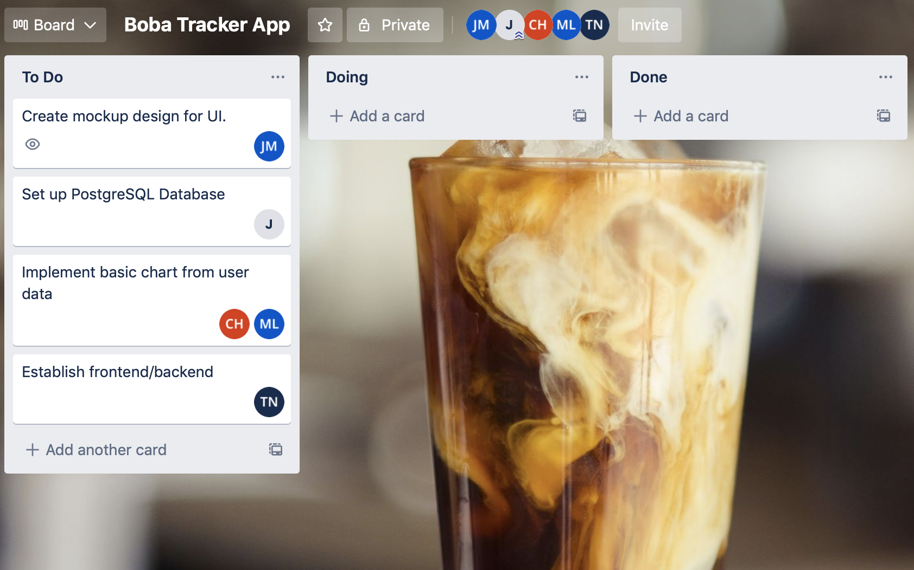

**BURNUP CHART**

**SCRUM TIMES**

* **MWF - 7pm PST** (Team Stand Up)
* **Thu - 3:30 PST** (Weekly TA Stand Up)